Recharge Self-Certification Form - Connection to Calreporting - Job Aid:

Contact: campus recharge lead: recharge_certification@berkeley.edu

This job aid will help you locate the recharge self-certification form and connect the file to Calreporting to bring in financial data from the data warehouse.

How to access the Self-Certification Form excel document
- Please go to the Recharge website at the following link: recharge website
- The Certification Checklist Form is under the “Forms and Templates” section
- Select the Certification Checklist Form
- Click the excel file and Select Open
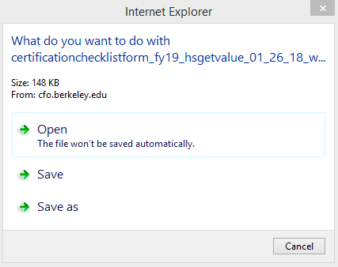

- Enter your Password if the window below opens then select Connect. Skip to the next bullet if you do not see this window.
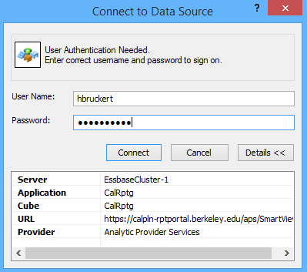

- Save the file on one of your computer drive on the network. Do not save the file on your desktop since the HSGETvalue coding build in the file will no longer function if you save the file to your desktop.
- If you do not have SMARTVIEW on your regular excel, login to CITRIX and select the SMARTVIEW excel icon to open your file.

How to refresh the Financial Trends tab (the Tolerance Calculation tab is refreshed using the same process)
- Go to the “Financial Trends” tab
- Fill out the cells in light blue with your unit chartstrings
- For deptId, CF1 - CF2 entries, type in an underscore between the 1 or C1, C2 of the deptId/CF1-2 then the code. For example, deptId 24105 should be listed as 1_24105 and CF2 NKIMA should be listed as C2_NKIMA
- If you do not have a chartfield 1 or 2, then list “Chart1” and “Chart2”.
- Select the SMARTVIEW tab at the top
- Select the “Panel” button in the top left corner in order to create a connection with the database.
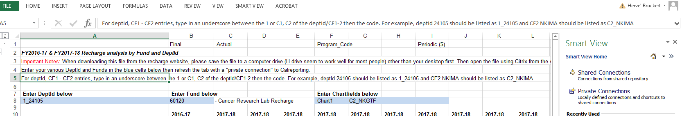

- On the right hand side of your screen Select "Shared Connections"
- Select a data source using the dropdown menu just below “Shared Connections”.
- Select "Oracle Essbase"
- Select the "+" sign to the right of "EssbaseCluster-1".
- Select the "+" sign next to "CalRptg", double click the new “CalRptg” sub menu
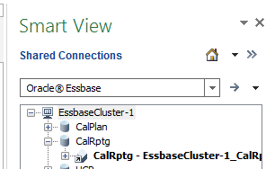
- Select "Ad Hoc Analysis" in the bottom right corner of your screen
- You might see the message below and if you do just click OK.
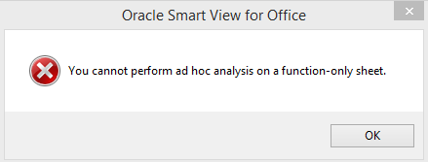
- Select “Add to private connection” at the bottom
- 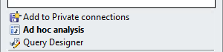
- Go back to the shared connections section above
- Select the small house icon
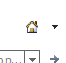
- Select Private Connection
- Select the dropdown in the “Select Server or enter Provider url” section.
- If this dropdown is empty, go back to the shared connection and at the bottom of the page select “add to private connection”. The try again to select the Private Connection.
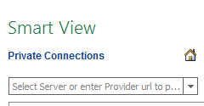
- Click on Essbase – EssbaseCluster – 1 then
CalRtp then CalRtp – EssbaseCluster-1_CalRtp
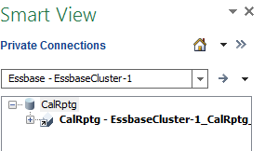
- Select “Ad hoc analysis” in the bottom right corner of your screen
- You might see the message below and if you do just click OK.
- You have now established the connection to the private connection and are ready to refresh the data.
- Select the “SMARTVIEW” tab on top
- Select refresh
- Your data should now be visible

Please contact the campus recharge lead at recharge_certification@berkeley.edu if you have challenges and / or suggestions on how to improve this job aid.

